WSA - HW – 9 :

7. Find and document any solutions that can be used in cooperation with the Distributed File System Replication (DFS-R) features and provides file locking over all replication members.

For Basic Team File Sharing and Collaboration

Originally designed to provide an easy and integrated way of replicating a limited amount of important documents for read-only access to branch offices or vice versa, Microsoft® Distributed File System Replication (DFSR) offers the potential for a more collaborative and productive way of working.
As organizations utilize DFSR for file sharing and collaboration, they quickly discover that file version conflicts and corruptions occur when multiple users attempt to simultaneously change the same file that was previously replicated across different servers. This is caused by the lack of a file locking mechanism in DFSR, which would prevent simultaneous edits across mirrored file systems.
Even a small organization can have hundreds, if not thousands, of potential file conflicts--caused by lost edits and the need to manually gather and merge changes from multiple file versions--resulting in user frustration and reduced productivity.

Enabling Collaboration with File Locking

The best and most complete way to eliminate file version conflicts when utilizing DFSR is to add and deploy a file locking solution. Such a solution needs to minimally provide real-time detection of file use coupled with immediate remote file locking.
PeerLock is a best-of-breed file locking solution designed to integrate seamlessly with Microsoft DFSR, which has no file locking capabilities. Together they provide a cost-effective, easy to deploy, basic file collaboration environment that is in use today in thousands of organizations worldwide.

Some solution 1:

- PeerLock

Some intro

File Locking for Microsoft DFSR

PeerLock Server provides network file locking while local shared files are in use. This ensures that when a user is modifying a file, no other user will be allowed to make changes to that file on any machine that is part of the PeerLock configuration. PeerLock integrates seamlessly with Microsoft DFSR or PeerSync Server to create a comprehensive collaboration environment.

This example shows PeerLock holding a lock on the files in Hong Kong and Washington while the file in Munich is in use. As soon as the file is closed, PeerLock will release the locks, and DFSR can replicate the file.

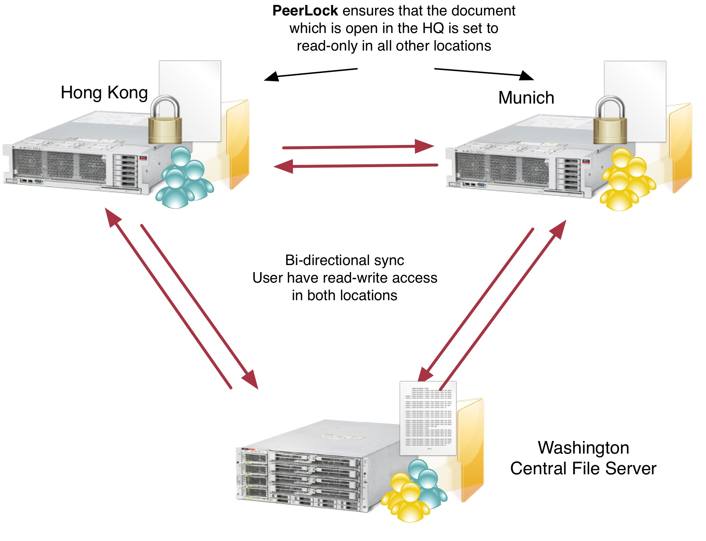

PeerLock can also be deployed with Peer Software’s PeerSync to create file collaboration environments that offer better performance and are easier to manage.

More info:
http://www.peersoftware.com/solutions/file-locking-for-ms-dfsr.html
http://www.peersoftware.com/products/file-collaboration/peerlock.html

Some solution 2:

- WAFS

Some intro

Wide Area File Services (WAFS)

Instantly access and share files across multiple offices worldwide
- Collaborate on mission-critical files
- Minimize data latency
- Real-time file locking
- Work offline when Internet connectivity is limited
- Works with Autodesk® Revit®
- File replication and sharing at LAN speeds

WAFS transparently replicates files to or between servers or desktops on any scale, while boosting performance—and with the Vault, there is no need for a backup solution in every office. All locations save their files to the Vault, as shown below.

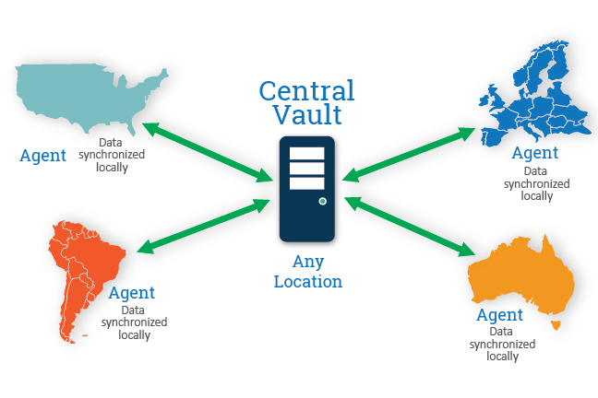

More info:
http://www.globalscape.com/wafs

Aditional
Some info about DFS and DFS-R / DFS-N:
http://technet.microsoft.com/en-us/library/cc787066%28v=ws.10%29.aspx
http://technet.microsoft.com/en-us/library/cc753479%28v=WS.10%29.aspx
http://support.microsoft.com/kb/2533009

